**LAB Manual 19**

**Rider**

* Glowing LineSegment
* Car Character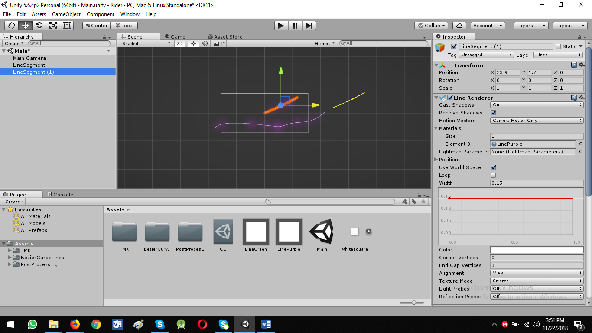

Now duplicate the material: LinePurple: Ctrl + D, rename it to LineGreen to show new duplicated line with green color and make some settings

Let’s start to add Car Character

* Drag the car.psd to unity assets
* Then drag to scene view
* Pixel per Unit: 150

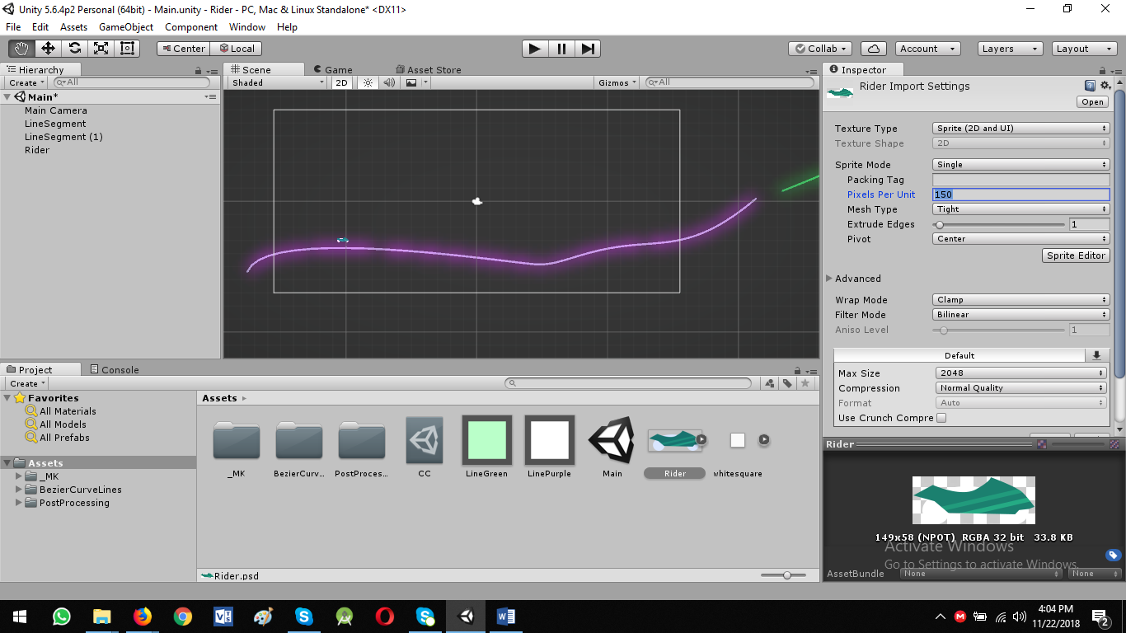

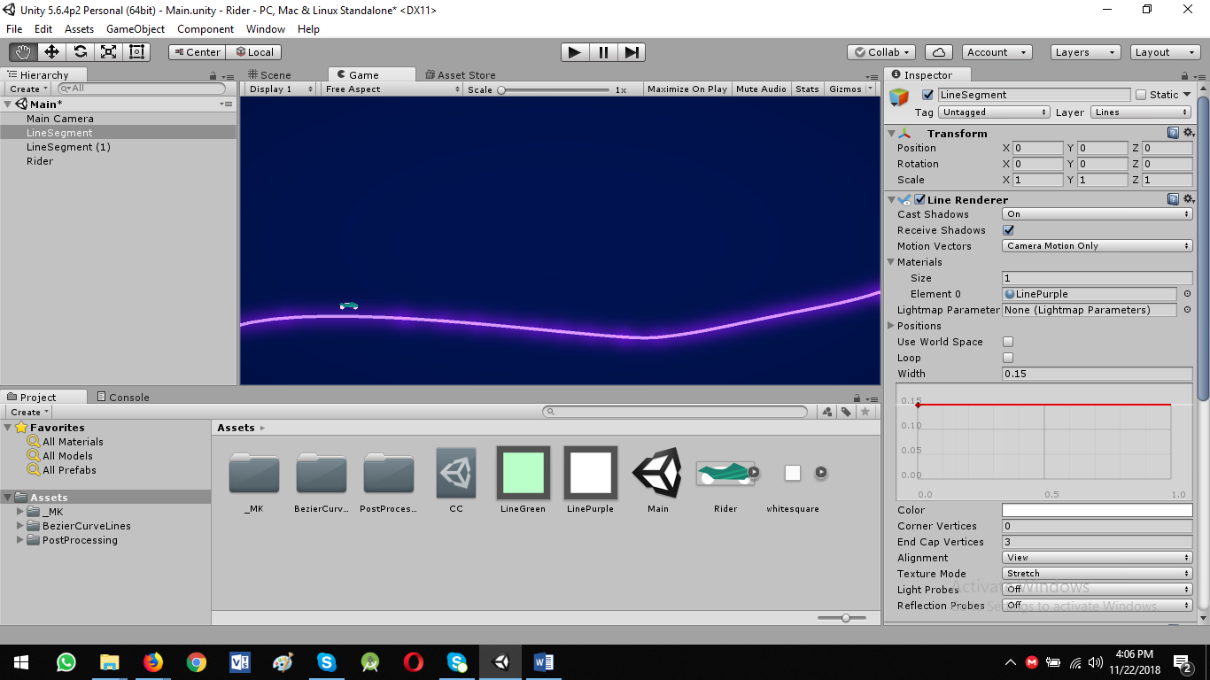

Add Collider to our Character

* Add component: Polygon Collider 2D
* Enable Edit Collider
* Delete any collision shape: Ctrl + Click

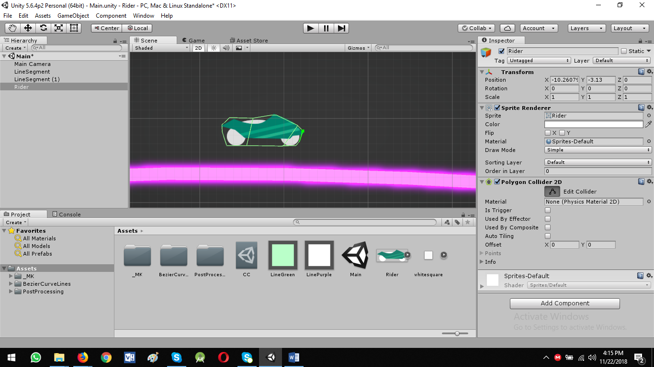

Add Rigidbody 2D

* Add Component: Rigiddody 2D

Physics Settings to behave correctly

* Mass: 5 - works pretty well
* Linear Drag: 0.3 - Smooth drive
* Angular Drag: 3
* Collision Detection: Continuous

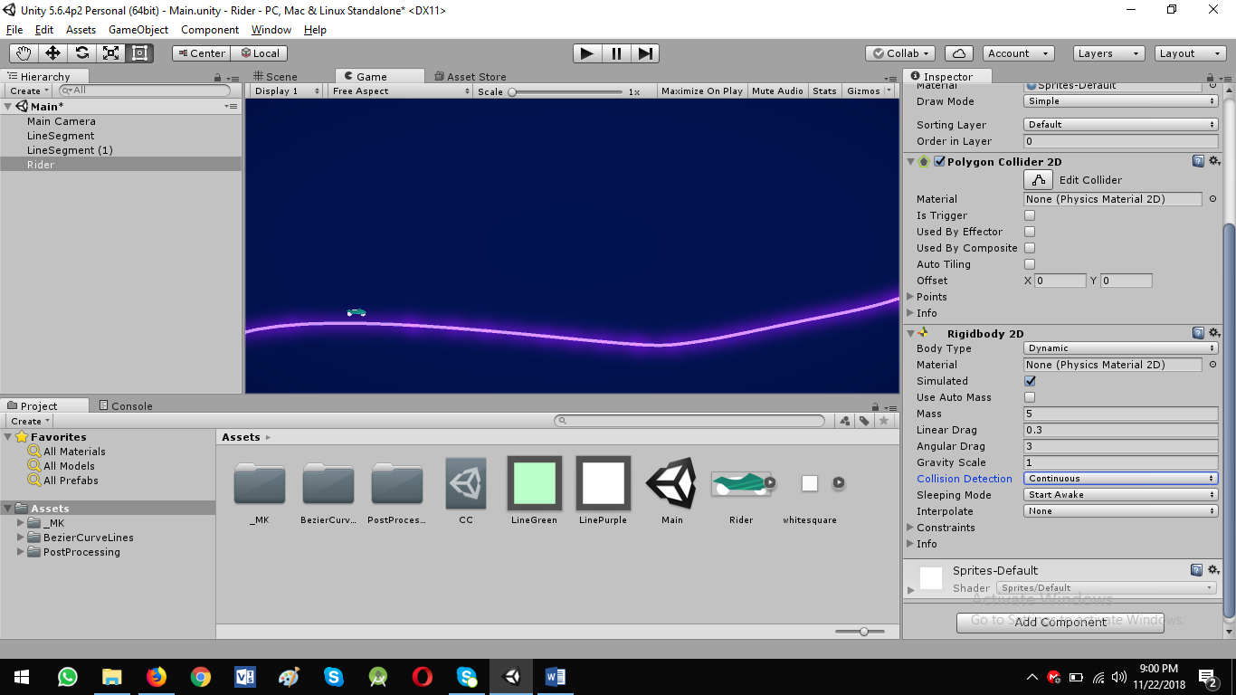

After applying these settings car is still on line. Friction is required between these two elements

ADD Friction Material:

* Right click in assets panel: Create -> Physics Material 2D
* Rename: RiderPhysicsMat

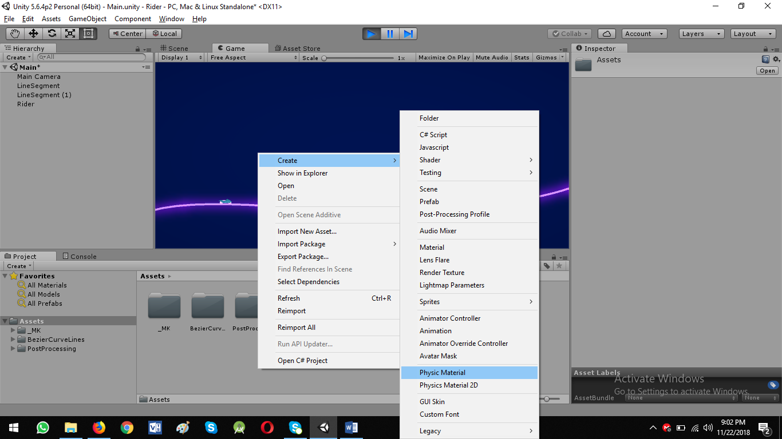

* Drag to rider: Rigidbody 2D: Material

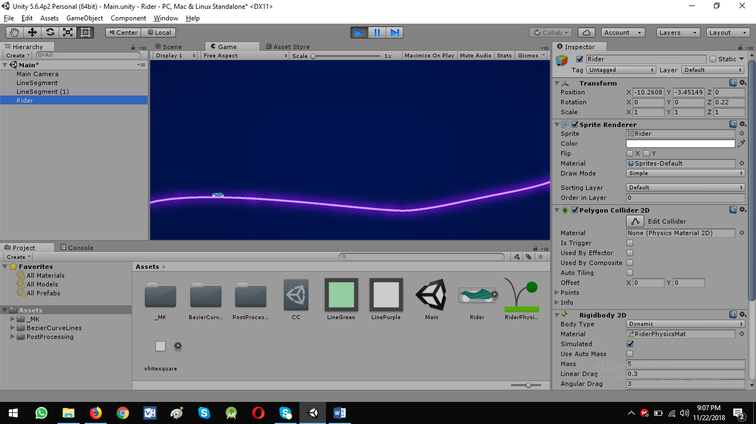

* Select RiderPhyscisMat: Set Friction: 0

Now go ahead and actual controls

* Add Component: CarController

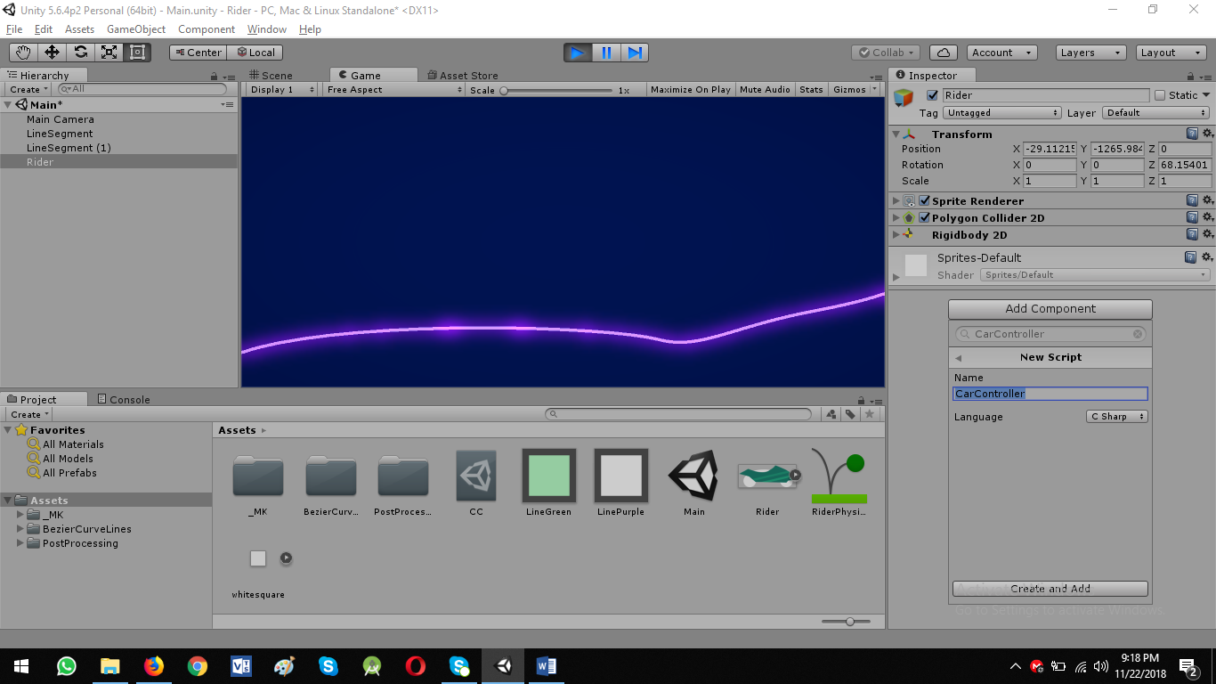

* Double click on carcontroller to open it in Visual Studio/Mono-Develop Unity

CarController.cs

using System.Collections;  
using System.Collections.Generic;  
using UnityEngine;  
  
public class CarController : MonoBehaviour {  
  
    private bool move = false;  
  
    private void Update(){  
        if (Input.GetButtonDown ("Fire1")) { *// Mouse left click button pressed*  
            move = true;  
        }  
        if (Input.GetButtonUp ("Fire1")) { *// Mouse right click button released*  
            move = false;  
        }  
    }  
}

***You can check in debug mode. move variable shows on/off on mouse left click/released***

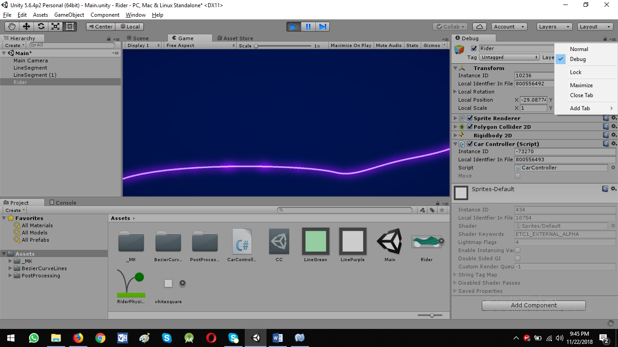

What is difference between Update() and FixedUpdate()

**Update():**

1. Used to getting inputs

2. Called when camera draw a frame

**FixedUpdate():**

**1.** used for moving and controlling physics of our car

2. Called after fixed interval

Update the Script to move car forward/right

using System.Collections;  
using System.Collections.Generic;  
using UnityEngine;  
  
public class CarController : MonoBehaviour {  
  
    private bool move = false;  
  
    public Rigidbody2D rb;  
  
    public float speed = 20f;  
  
    private void Update(){  
        if (Input.GetButtonDown ("Fire1")) { *// Mouse left click button pressed*  
            move = true;  
        }  
        if (Input.GetButtonUp ("Fire1")) { *// Mouse left click button released*  
            move = false;  
        }  
    }  
  
    private void FixedUpdate(){  
        if (move == true) {  
            rb.AddForce ( transform.right * speed * Time.fixedDeltaTime * 100f , ForceMode2D.Force);  
              
        }  
    }  
}

Rider: Drag rigidbody 2D to CarController Script: Rb

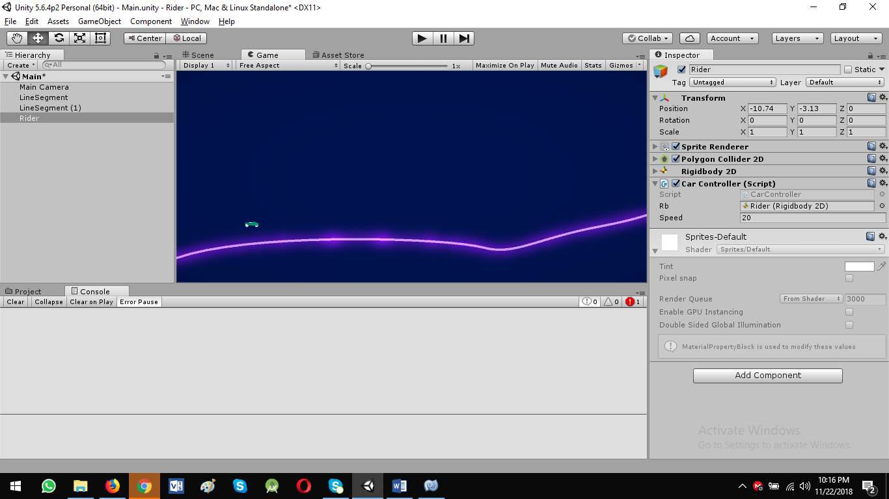

**Now we want that our camera fallow around our car**

* Select Main Camera
* Add new component: CameraController script
* **LateUpdate():** Called at the end of drawing frame

**CameraController.cs**

using System.Collections;  
using System.Collections.Generic;  
using UnityEngine;  
  
public class CameraController : MonoBehaviour {  
  
  
    public Transform target;  
    public Vector3 offset;  
  
    private void LateUpdate(){  
        Vector3 newPos= target.position + offset;  
        newPos.z = transform.position.z;  
        transform.position = newPos;  
  
      
    }  
}